
Lesson 14 Teacher's Key: Raising the Stakes
Scratch - Instructor Reference Only
VIDEO GAME CREATION

What This Lesson Teaches
Replacing two hardcoded literals (a fixed spawn count, a fixed movement speed) with formulas keyed off the wave variable - the payoff lesson for simplifications flagged as deliberate back in Lesson 11.

Level 1 - Full Worked Solution
- "repeat (4 + wave)" and "set enemies_remaining to (4 + wave)" must use the identical expression - any mismatch between them is exactly the kind of bug this Key's troubleshooting section calls out.
- No new variables are needed for Level 1 - this is purely a formula change to numbers that were already there.
- Wave 1 still spawns exactly 5 (4 + 1 = 5), so nothing about the game's opening feel changes - only later waves escalate.
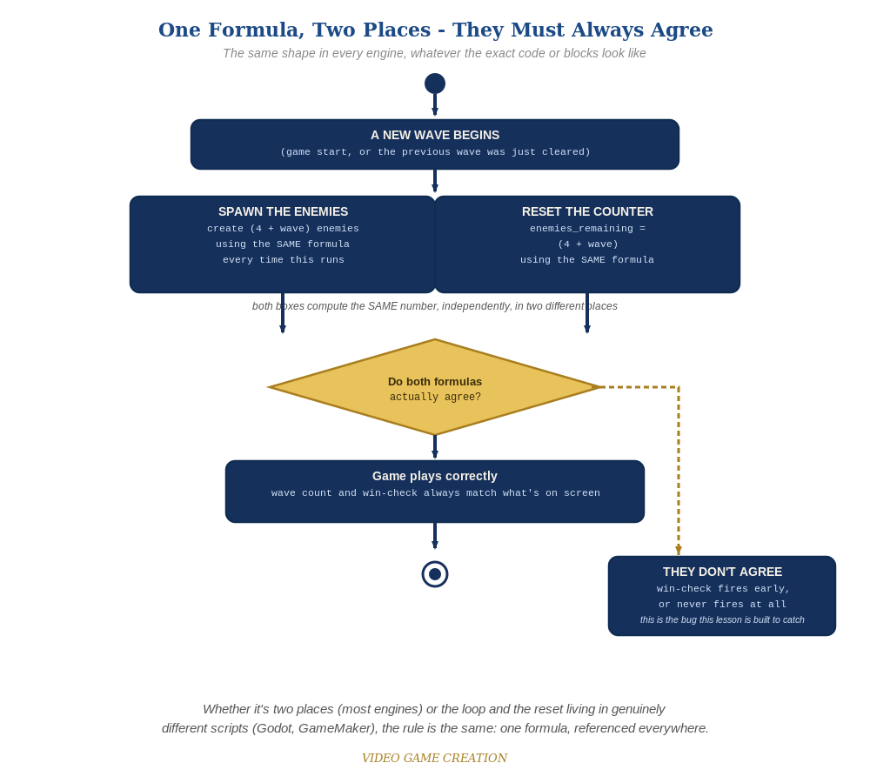
Whether the spawn loop and the reset live in two places or two genuinely different scripts, the rule is the same: one formula, referenced everywhere.

Why This Structure
- Deriving both the spawn count and the enemies_remaining reset from the SAME formula (rather than one being "4 + wave" and the other a separately-updated literal) is the exact same discipline as Lesson 11's "broadcast [spawn enemies]" reuse - one source of truth, referenced everywhere it's needed.
- Starting the formula at "4 + wave" (rather than, say, "5 * wave") keeps wave 1 unchanged and growth gentle - worth discussing as a game-balance decision, not just a math one.

Level 2 / Level 3 Talking Points
- Ask students to compute the wave 1/2/3 enemy counts by hand from the formula before running it, then confirm the game matches.
- For strong students: discuss what would happen with a much steeper formula (e.g. "5 * wave") - wave 3 would have 15 enemies, likely overwhelming for a 3-wave game. A good real discussion about tuning difficulty, not just implementing it.

Common Student Mistakes
- Updating the spawn loop's count but forgetting to update enemies_remaining's reset value (or vice versa), causing the win-check to fire early or never.
- Using a different formula in two different places by accident (e.g. "4 + wave" in one, "5 + wave" in another).
- For Level 2: forgetting to recalculate enemy_speed inside the spawn-enemies script itself, so it only ever gets wave 1's value.

